Stage Plan

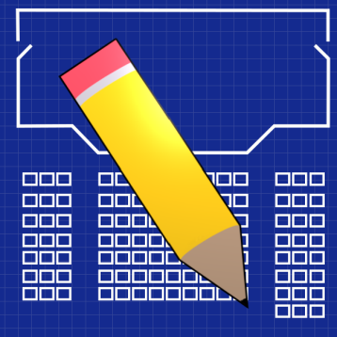
User’s Manual
Document

Ben Marshall, Lane Addison, Milton Moore, Jason Milloff, Ksenia Belikova

12/08/16
USER'S MANUAL
TABLE OF CONTENTS
Page #
1.0 GENERAL INFORMATION 3
1.1 System Overview 3
1.2 Authorized Use Permission 3
1.3 Points of Contact 3
1.3.1 Information 3
1.3.2 Coordination 3
2.0 SYSTEM SUMMARY 4
2.1 System Configuration 4
2.2 Data Flows 4
2.3 User Access Levels 4
3.0 QUICK START GUIDE 5
3.1 Logging On (Gaining Access to the System) 5
3.2 System Menu 5
3.2.1 New Stage Layout (Ctrl + N) 8
3.2.2 Open Stage Layout (Ctrl + O) 8
3.2.3 Save Stage Layout (Ctrl + S) 8
3.2.4 Print Stage Layout (Ctrl + P) 8
3.2.5 Toggle Flyrail 8
3.2.6 Dragging and Dropping Stage Objects 9
3.2.7 Selecting/Deselecting Stage Objects 9
3.2.8 Cutting Stage Objects (Ctrl + X) 9
3.2.9 Copying Stage Objects (Ctrl + C) 9
3.2.10 Pasting Stage Objects (Ctrl + V) 9
3.2.11 Rotating Stage Objects (Ctrl + R) 9
3.2.12 Deleting Stage Objects (Delete Key) 9
3.2.13 Adding Textboxes 10
3.2.14 Editing Textboxes 10
3.2.15 Undo (Ctrl + Z) 10
3.2.16 Redo (Ctrl + Y) 10
3.2.17 Editing Available Stage Objects 10
3.2.18 Cloning Available Stage Objects 10
3.2.19 Importing New Stage Objects 11
3.2.20 Deleting Available Stage Objects 11
3.4 Exiting the System 11
3.5 Special Instructions for Error Correction 11
3.6 Caveats and Exceptions 11
4.0 FUTURE ENHANCEMENTS 12
4.1 Future Functionality 12
4.2 Similar Systems – Additional Functionality 12
4.3 Maintenance Capabilities 12

GENERAL INFORMATION

1.1 System Overview

Stage Plan is a desktop application for that is designed to help members of the auditorium at Radford University to be able to generate stage layouts for performances. Stage Plan shall allow the stage manager to generate a prop setup for various different scenes during a rehearsal or performance. The user shall also be able to save and load layouts and print a hard copy for use during the rehearsals. Since this application is a desktop based program, no internet connection shall be needed to access the software.

To install Stage Plan, the user should obtain the executable setup file from the ReadySETgo website at http://readysetgoradford.weebly.com/. Upon running the setup file, the user shall select an installation directory, and Stage Plan shall be installed. Shortcuts shall then be created on the user’s desktop, and in their start menu. After initial setup, Stage Plan can be launched from its installation directory, or via the generated shortcuts.

1.2 Authorized Use Permission
This software is authorized for use by the stage manager and assistant stage manager at Bondurant Auditorium at Preston Hall in Radford University. This software is not authorized for redistribution.

1.3 Points of Contact

1.3.1 Information
For Troubleshooting & Maintenance: Contact Jason Milloff at rsgStagePlan@gmail.com

1.3.2 Coordination
The client should not need any further coordination with ReadySETgo. However, the client may contact Jason Milloff for help if needed. (See section 1.3.1)

SYSTEM SUMMARY

2.1 System Configuration
Stage Plan requires Java Runtime Environment 1.8.0 or later, which can be downloaded at https://www.java.com/en/download/. If the user does not have the necessary runtime environment, they will be prompted to download it when they run the setup executable.

For general use, only a keyboard and mouse are required. To print stage layouts, a printer is required.

2.2 Data Flows
When a stage layout is saved, it is saved to a location that the user specified, where it can be re-opened later. Information stored in saved files includes the objects and textboxes on the stage, as well as their locations, and the states of the flyrails.

When the user creates a new drag and drop stage object, a configuration file in the installation directory keeps track of the addition, and allows it to be used after closing and reopening the application. If the user specifies an image file to use for that object, the image will be copied into the installation directory, and the original can be safely deleted.

2.3 User Access Levels
Stage Plan is a standalone desktop application, and as such has no user levels or access restrictions.

QUICK START GUIDE

3.1 Logging On (Gaining Access to the System)
To access the system, the user should open the executable in the installation directory, or one of the shortcuts to the executable generated during installation.

3.2 System Menu

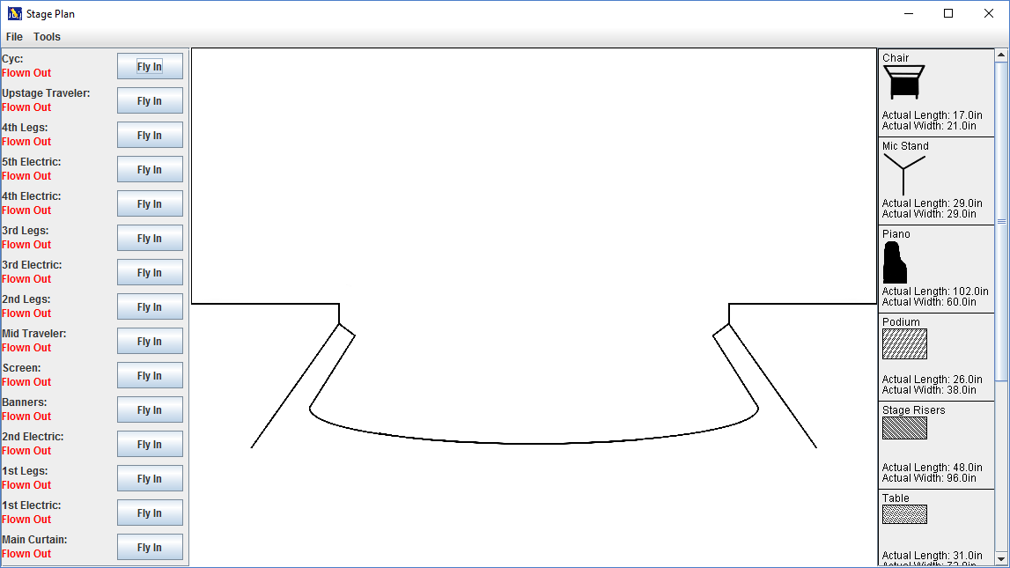
Figure 1: This is the user interface that the application opens up to.

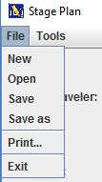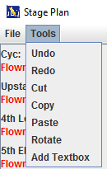
Figure 2: The File Menu Figure 3: The Tools Menu
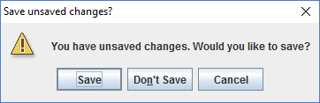
Figure 4: The save prompt

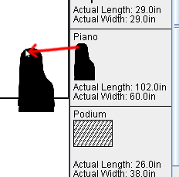
Figure 5: Dragging and Dropping

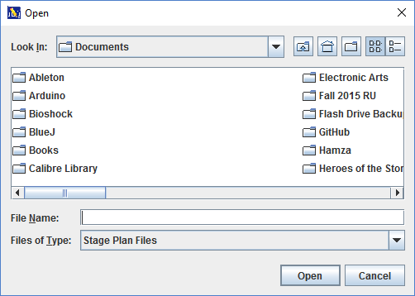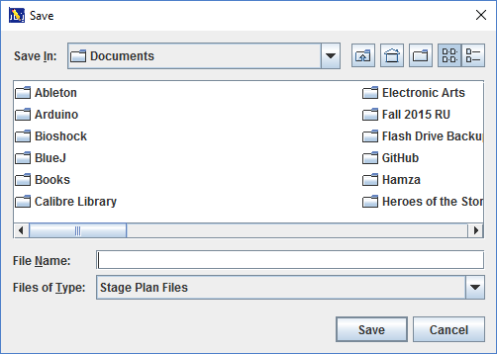
Figure 6: The open dialog Figure 7: The save dialog

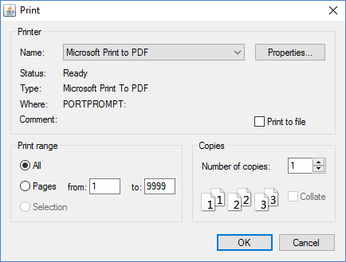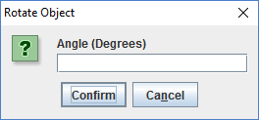
Figure 8: The print dialog Figure 9: The rotation dialog
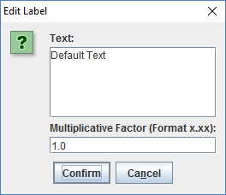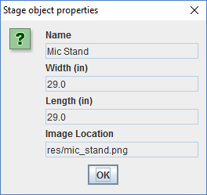
Figure 10: The edit textbox dialog Figure 11: The properties dialog

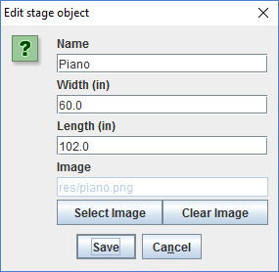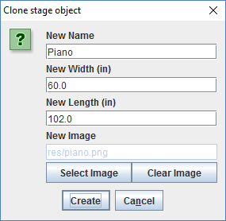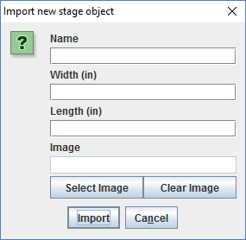
Figure 12: The edit stage object dialog Figure 13: The clone stage object dialog Figure 14: The import stage object dialog

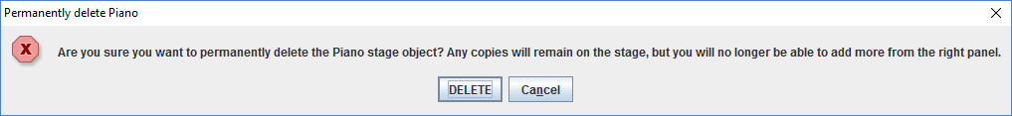
Figure 15: The deletion confirmation

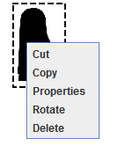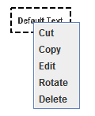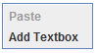
Figure 16: Object right-click menu Figure 17: Text right-click menu Figure 18: Stage right-click menu

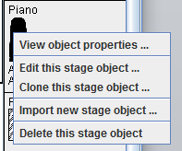
Figure 19: Object panel right-click menu

3.2.1 New Stage Layout (Ctrl + N)
(See Figure 2 and 4)
The application will open up to a blank stage layout. However, a blank layout can also be created by navigating to “File” -> “New” or by pressing “Ctrl + N”. The average response time is less than 1 second. If the current layout has unsaved changes, they will be prompted to save before the blank layout is created.

3.2.2 Open Stage Layout (Ctrl + O)
(See Figures 2, 4, and 6)
A saved stage layout can be loaded by navigating to “File” -> “Open” or by pressing “Ctrl + O”. The average response time is less than 1 second. If the current layout has unsaved changes, they will be prompted to save before the saved layout is loaded.

3.2.3 Save Stage Layout (Ctrl + S)
(See Figures 2 and 7)
The current stage layout can be saved by navigating to “File” -> “Save” or by pressing “Ctrl + S”. If the file had previously been saved, the file will be saved without displaying a prompt. Otherwise, a dialog will appear where the user may specify a location and filename. If the user has already saved, and wishes to save the file with a new name, they may navigate to “File” -> “Save as” to display the dialog. The average response time is less than 1 second.

3.2.4 Print Stage Layout (Ctrl + P)
(See Figures 2 and 8)
The current stage layout can be printed by navigating to “File” -> “Print” or by pressing “Ctrl + P”. A dialog will appear where the user may specify their desired printer, and press “Print”. The average response time shall very according to printer, but was less than 5 seconds during our testing.

3.2.5 Toggle Flyrail
(See Figure 1)
Each flyrail in the left panel can be toggled by pressing the corresponding button which says “Fly in” or “Fly out.” After pressing the button, the button text will change, and the flyrail object will be displayed or removed from the stage. Average response time is less than 1 second.

3.2.6 Dragging and Dropping Stage Objects
(See Figure 5)
Each stage object on the right panel can be dragged and dropped onto the stage by pressing the left mouse button when over the object, dragging to the stage, and releasing. Once on the stage, objects can again be dragged and dropped in the same manner for repositioning. Average response time is less than 1 second.

3.2.7 Selecting/Deselecting Stage Objects
An object on the stage can be selected by clicking it. Once selected, it will have a dashed border around it. It can be deselected by clicking an empty area of the stage. Average response time is less than 1 second.

3.2.8 Cutting Stage Objects (Ctrl + X)
(See Figures 3, 16, and 17)
The selected stage object can be cut into the clipboard for later pasting by navigating to “Tools” -> “Cut” or by pressing “Ctrl + X”. Alternatively, any stage object can be right-clicked, and cut can be selected from the right-click menu. Average response time is less than 1 second.

3.2.9 Copying Stage Objects (Ctrl + C)
(See Figures 3, 16, and 17)
The selected stage object can be copied into the clipboard for later pasting by navigating to “Tools” -> “Copy” or by pressing “Ctrl + C”. Alternatively, any stage object can be right-clicked, and copy can be selected from the right-click menu. Average response time is less than 1 second.

3.2.10 Pasting Stage Objects (Ctrl + V)
(See Figures 3 and 18)
A previously cut or copied stage object can be pasted by navigating to “Tools” -> “Paste”, by pressing
“Ctrl + V”, or by right-clicking the stage and selecting paste from the right-click menu. Average response time is less than 1 second.

3.2.11 Rotating Stage Objects (Ctrl + R)
(See Figures 3, 9, 16 and 17)
The selected stage object can be pasted by navigating to “Tools” -> “Rotate” or by pressing “Ctrl + R”. A dialog will appear wherein the user may enter a new angle of rotation. After confirming, the object’s new rotation will be set. Alternatively, the user may right click the object and select “Rotate” from the right-click menu. Average response time is less than 1 second.

3.2.12 Deleting Stage Objects (Delete Key)
(See Figures 3 and 16)
The selected stage object can be deleted by navigating to “Tools” -> “Delete” or by pressing the “Delete” key. Alternatively, an object can be deleted by right-clicking on the object and selecting “Delete” in the right-click menu. Average response time is less than 1 second.

3.2.13 Adding Textboxes
(See Figures 3 and 18)

A textbox can be added to the stage by navigating to “Tools” -> “Add Textbox” or by right-clicking on the stage and selecting “Add Textbox”. A textbox containing “Default Text” will appear on the stage. For cut, copy, and paste operations, textboxes operate like any other stage object. The average response time for adding textboxes is less than 1 second.

3.2.14 Editing Textboxes
(See Figures 10 and 17)
All textboxes may be edited by double-clicking or by right-clicking and selecting “Edit Textbox”. A dialog will appear where the user may change the text and multiplicative factor. The multiplicative factor is used to change text/textbox size. It has a default value of 1.00. The user can increase text size by using a multiplicative factor over 1.00 (ex. 2.25) or decrease text size by using a multiplicative factor below 1.00 (ex. 0.50). The average response time is less than 1 second.

3.2.15 Undo (Ctrl + Z)
(See Figure 3)
All actions performed in the current session can be undone. User can undo the last action one action at a time starting by navigating to “Tools” -> “Undo” or by pressing “Ctrl + Z”. The average response time is less than 1 second.

3.2.16 Redo (Ctrl + Y)
(See Figure 3)
The user can redo an undone action by navigating to “Tools” -> “Redo” or by pressing “Ctrl + Y”. If the user changes something on the stage after undoing, they will no longer be able to redo. The average response time is less than 1 second.

3.2.17 Editing Available Stage Objects
(See Figures 6, 12, and 19)
The user can edit an existing right panel object by right clicking an object on the right panel and selecting “Edit stage object…” A dialog will appear where the user may edit name, the object’s actual height and width in inches, and image. Upon pressing “Save”, the right panel object will have those new properties, but any existing copies on the stage will remain the same. Average response time is less than 1 second.

3.2.18 Cloning Available Stage Objects
(See Figures 6, 13, and 19)
The user can clone an existing right panel object by right clicking an object on the right panel and selecting “Clone stage object…” A dialog will appear where the user may edit name, the object’s actual height and width in inches, and image. Upon pressing “Create”, the new object will be added to the right panel. Average response time is less than 1 second.

3.2.19 Importing New Stage Objects
(See Figures 6, 14, and 19)
The user can add a new object to the list on the right panel by right clicking anywhere on the right panel and selecting “Import new stage object…” A dialog will appear where the user should enter in a name, and the object’s actual height and width in inches. Optionally, they may also select an image to use. If none is selected, a default image will be used. Average response time is less than 1 second.

3.2.20 Deleting Available Stage Objects
(See Figure 19)
The user can permanently remove an object from the right panel by right clicking that object on the right panel, and selecting “Delete this stage object.” The user will be prompted to confirm the deletion. Average response time is less than 1 second.

3.4 Exiting the System
The user may exit the program via the “X” in the top right corner, or via the File -> Exit menu option (See Figures 1 and 2 in Section 3.2). To safely close the program without losing any work, the user should first save according to any of the methods given in Section 3.2.3. If the user attempts to exit without saving their work, they shall be prompted to save or discard their changes.

3.5 Special Instructions for Error Correction
The only place where a user may run into special error situations is when dealing with file loading and image importing. When the user tries to load invalid/corrupt file data, or they try to access a file without permission, the system will show an error dialog, containing a description of the problem. It is then up to the user to take actions necessary to gain access or repair the file in question.

3.6 Caveats and Exceptions
The user must press save in order to save their stage layout file, however they will also be prompted to do so if they attempt to exit while there are unsaved changes. Any other function restrictiveness is taken care of by the system.

FUTURE ENHANCEMENTS

4.1 Future Functionality
We covered all of the functionality that was needed by our client. However, if we wanted to add on to it in the future, we could allow the user to customize the stage and flyrail system, which would expand our client base to any stage managers. We would also like to improve the fonts for textboxes, and create more variety for object generation (more colors, shapes, etc…).

4.2 Similar Systems – Additional Functionality
- Stage Plot Designer – Has additional stage props which our client did not request, but could be nice to have. (Mainly musical instruments)
- Stage Plot Pro – All of Stage Plot Pro’s props appear to be processed top-down photographs of the respective stage objects. If we had more time, this would have been on our todo list.
- MyStagePlan – MyStagePlan runs in the browser. It would be nice to have the additional cross platform ability of running in the browser, but that was outside our scope.

4.3 Maintenance Capabilities
For all maintenance, feature requests, and bug fixes, the user should contact Jason Milloff according to the information given in Section 1.3.1.

